- INTRODUCTION
  - About Project
RideSwift is a user-friendly ride-sharing web application designed to simplify urban travel by connecting passengers with nearby drivers. Built using the MERN stack (MongoDB, Express.js, React.js, and Node.js), RideSwift offers an intuitive and visually appealing interface for both riders and drivers. Key features include real-time ride booking based on location and destination, transparent fare estimates, driver tracking, secure online payments, and user registration for a personalized experience. Drivers benefit from a comprehensive admin dashboard to manage ride requests, earnings, and availability. In essence, RideSwift streamlines the ride-booking process for both commuters and drivers, offering a reliable and efficient transportation alternative.
Key Features:
a) User Login and Registration (for both riders and drivers)
b) Ride Booking Interface (based on pickup and drop location)
c) Ride History Tracking (for both users and drivers)
d) Secure Authentication using JWT (for safe session management)
e) Admin Panel for Ride, Driver, and User Management

- PROBLEM INVESTIGATION
2.1 Goal & Objectives
RideSwift aims to create an efficient platform to bridge the gap between drivers and passengers in a city environment, ensuring comfort, reliability, and affordability.
.
Objectives :
• To enable real-time ride booking with live driver location.
• To simplify urban transportation with a centralized ride-sharing system.
• To enhance user experience with fare transparency and feedback system.
• To provide admins and drivers with a powerful management panel.
• To reduce waiting time for passengers.

2.2 Feasibility Analysis

Feasibility analysis is a test of system proposal regarding its work ability, and ability to meet user need, effective use of resources. Thus when a new application is proposed it normally goes through a feasibility analysis before it is approved for deployment.

Technical Feasibility: This system is technically feasible because React.js used as a frontend and also used MongoDB as a backend because it is an open source tools.

Economic Feasibility: I am developing the website at the learning stage so it is difficult to determine the cost of the system and to decide that the project is economical feasible or not.

c) Operational Feasibility: All operations are feasible and user friendly. All operations are easy for achievable. The proposed system satisfies the admin and customer's needs. The interface is extremely user friendly.

2.3 Solution suggested

- Develop a fast and responsive web application for booking and ride tracking.
- Ensure secure logins and session handling for riders and drivers.
- Build a centralized system for fare estimates, ride requests, and driver allocation

- SYSTEM ANALYSIS
System analysis is a problem-solving technique that breaks down a system into its component parts in order to evaluate how well those components perform and interact to achieve their goals.
  - Introduction to Existing System
Traditionally, car booking has involved:
- Offline methods: Visiting car rental agencies, contacting service providers directly through phone calls or emails, or browsing physical catalogs..
- Online Booking Platforms: Websites like Expedia or Kayak that offer car rentals from various operators.
  - Limitations of Existing System
These existing systems have limitations that RideSwift aims to address:
  - Limited selection: Offline methods may restrict options to local operators.
  - Lack of transparency: Information on car specifications, pricing based on kilometers, and cancellation policies might be scattered or unclear..
  - Limited reviews: Offline methods and some platforms might not offer a platform for user reviews, making it difficult to gauge service quality.
  - Inflexible payments: Offline booking might require cash or checks, while some online systems have limited payment gateway options.
  - Operator limitations: Existing systems might not offer a dedicated dashboard for car rental operators to manage bookings and customer information efficiently.
  - Introduction to proposed system
RideSwift is a user-friendly ride-sharing web application designed to simplify urban travel by connecting passengers with nearby drivers. Built using the MERN stack (MongoDB, Express.js, React.js, and Node.js), RideSwift offers an intuitive and visually appealing interface for both riders and drivers. Key features include real-time ride booking based on location and destination, transparent fare estimates, driver tracking, secure online payments, and user registration for a personalized experience. Drivers benefit from a comprehensive admin dashboard to manage ride requests, earnings, and availability. In essence, RideSwift streamlines the ride-booking process for both commuters and drivers, offering a reliable and efficient transportation alternative.
  - Merits of proposed system
- User friendly interface
- Seamless browsing and booking based kilometers.
- Secure online payment
  - Information Gathering
During this information gathering phase, I have collected valuable insights and knowledge about the RideSwift from various online resources, including websites, blogs, forums, YouTube tutorials, as well as sought guidance from project guide. This information served as a foundation for the successful development of this project.

  - Process Model Used
To develop a system there is a requirement of process model. It defines a process for each phase and check the status of this system. According to the need of proposed system the spiral model is best suited for it.

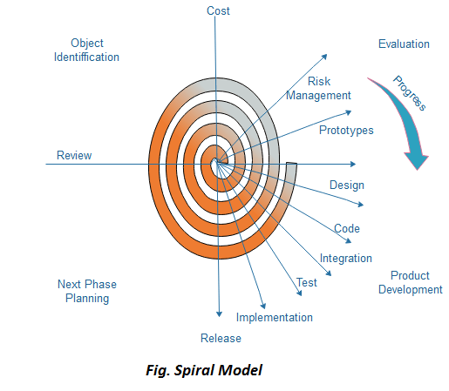
Figure 3.1 Spiral Model

  - Process chart

A process chart, also known as a flowchart or process flow diagram, is a visual representation of the steps or activities involved in a process or workflow.
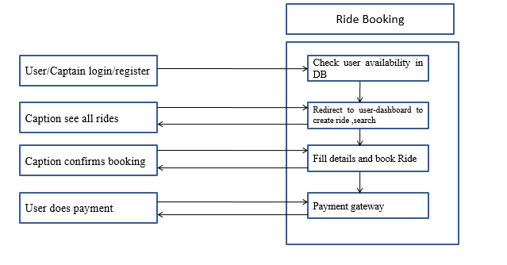

Figure 3.2 Process chart

  - Data Flow Diagram & Data Dictionary
A data flow diagram (DFD) is a blueprint for how information moves through a system.

0-Level DFD
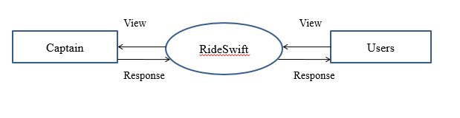

Figure 3.3 0-level DFD

1-level DFD

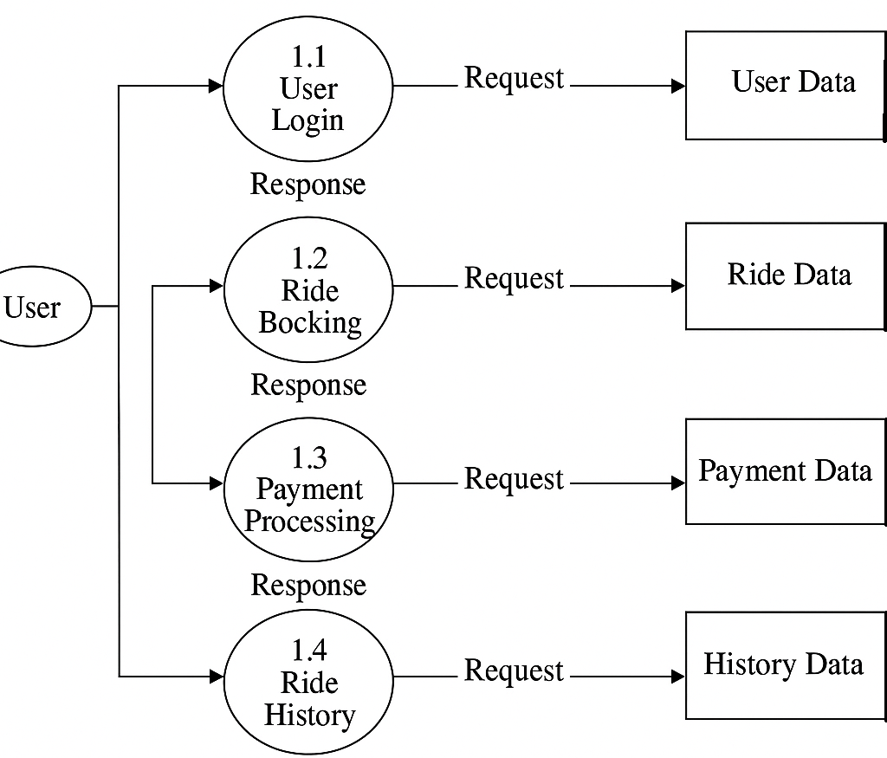
Figure 3.4. 1-level DFD

2- level DFD

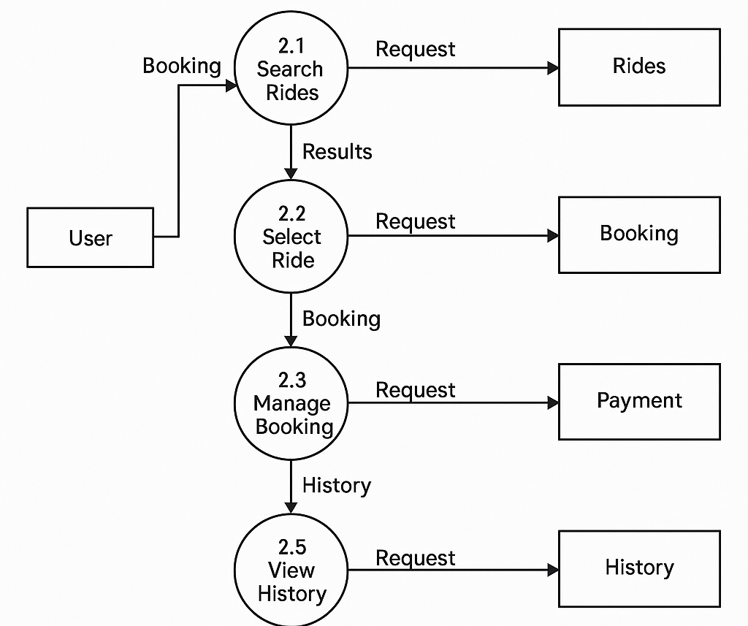
Figure 3.4 2-level DFD

Data Dictionary
A data dictionary is a document or database that provides detailed information about the data elements or attributes used in a database or information system.
- User login
a) Name: User login to the RideSwift system
b) Description: Handles login for both riders and drivers.
c) Input: Email ID and password
d) Output: Displays success or error message
e) Data structure:
Schema:
(_id, email, password, role)
Where _id is the primary key, email is unique, password is stored securely, and role determines if the user is a rider or captain.
ii. Ride Booking:
a) User ride creation and booking system
b) Description: Passenger requests a ride by providing details.
c) Input: Enter source, destination, date, and number of passengers
d) Output: Shows available drivers / estimated fare
e) Data structure:
Schema:
(rideId, userId, driverId, source, destination, fare, status, requestTime, startTime, endTime) Where _id is the primary key, rideType (user or captain), status tracks ride progress, and fare is calculated.

- PROJECT PLANNING
Project planning is the process of defining the objectives, scope, and activities required to complete the RideSwift project successfully.

  - Project Resources
    - Required Document
The required documents for the RideSwift project consist of:

Project Scope: Define the scope of the project, including the objective, purpose, and goals of the RideSwift app, such as enabling users to book rides and captains to accept them.

Technology Stack: List the tools and technologies that will be used to develop the RideSwift app. This might include software development frameworks, programming languages (e.g., Node.js, React), databases (e.g., MongoDB), and APIs (e.g., Google Maps for location services, Socket.IO for real-time communication).

System Architecture: Document the system architecture for implementing RideSwift. This includes defining the different modules (e.g., user authentication, ride creation, payment processing), the flow of data between these modules, and how they interact with each other.

Data Collection: Describe the methods for collecting data in the RideSwift app. This includes user profiles (e.g., email, phone, ride history), ride details (e.g., source, destination, fare, ride status), and transaction information (e.g., payment records).

Booking Process: Define the booking process in the RideSwift app. This includes how users select their source and destination, how captains confirm rides, and how the OTP verification and fare calculation are handled.

Implementation: Describe how you will implementation strategy for the RideSwift app. This includes integrating the various modules, conducting testing (unit tests, integration tests), and deploying the app to a production environment (e.g., using Vercel for the frontend and Heroku for the backend).

Security: security measures to protect user data and ensure safe transactions in the RideSwift app. This includes data encryption, secure authentication (e.g., JWT for user login), and protection against common vulnerabilities.

User Interface: Document the user interface for interacting with the RideSwift app. This includes designing a responsive dashboard for users and captains, ensuring an intuitive experience for ride creation, booking, and ride tracking. The UI will be designed using Tailwind CSS.

Maintenance and Support: Define the maintenance and support plan for the RideSwift app. This includes regular system monitoring, addressing user feedback, updating the app with new features or security patches, and offering customer support to users and captains.

    - Hardware Requirements
Table 4.1 Hardware Requirement
Component | Specification
Processor | Intel i3/Ryzen 3
RAM | 8GB
HDD | 1 TB
SSD | 256 GB

Table 4.2 Software Requirement
Component | Specification
Operating System | Window 10/11
Language | React.js ,Node.js ,Express.js
Database | MongoDB
Browser | FireFox, Google Chrome

    - Duration
The project completed in 2 month
4.2 Team Organization
Following table represents the individual work of the member that was involved in completing the project. Being an individual member of the team, I have done with my best of skills and knowledge in all the phases of the project.
Analysis | Deepanshu Rathore
Design | Deepanshu Rathore
Coding | Deepanshu Rathore
Testing | Deepanshu Rathore
Implementation | Deepanshu Rathore

Figure 4.1 Team Organization
  - Schedule
Task | No. of Days | Equivalent in Weeks
Analysis | 30 | 4 weeks 2 days
Design | 28 | 4 weeks
Coding | 20 | 2 weeks 6 days
Testing | 10 | 1 weeks 3 days
Documentation | 5 | 0 weeks 5 days

Figure 4.2 Schedule

- SYSTEM DESIGN
The most creative and challenging face of the system development is System Design. It provides the understanding and procedural details necessary for the logical and physical stages of development. The design step provides a data design, architectural design, and a procedural design.
  - Design Methodology
Unified Modeling language (UML) is a language for modeling. The UML uses mostly graphical notations to express the Object Oriented analysis and design of software projects. UML is a standard language for writing software blueprints. UML allow developing several different types of visual diagrams that represent various aspects of system.
- Use Case Diagram

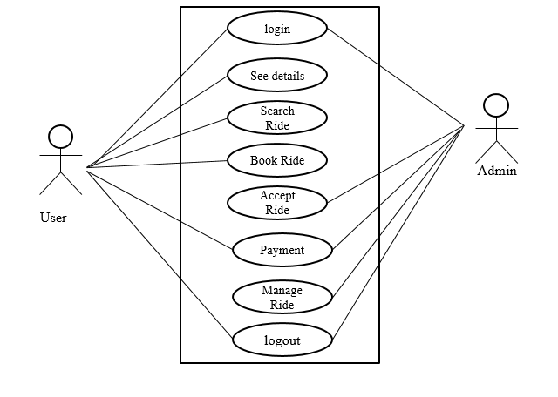
Figure 5.1 Use Case Diagram
- Activity Diagram
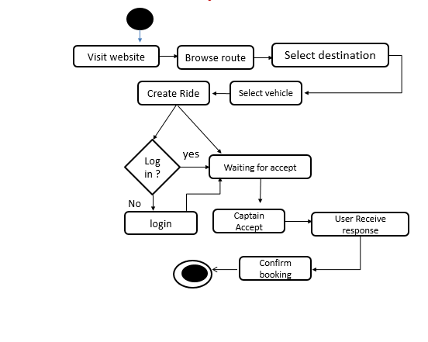
Figure 5.2 Activity Diagram

- Class Diagram
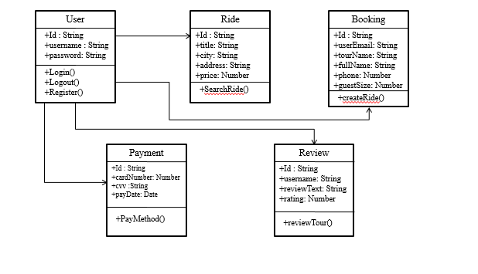
Figure 5.3 Class Diagram

- Sequence Diagram
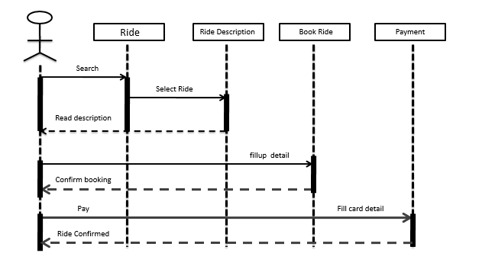
Figure 5.4 Sequence Diagram

  - Database Design
Database design includes the entity relationship diagram and table scheme for face recognition attendance management system.
    - ER Diagram
This ER Diagram is the graphical depiction of relationships between all the entities involved in the system. Its major components are Entities, Attributes, and Relationships. Figure 5.6 shows the ER Diagram for the system.

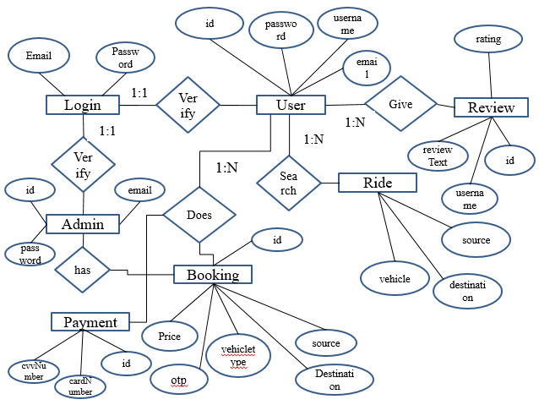

Figure 5.5 E-R Diagram

    - Table Structure
It defines the properties of an attribute for a certain entity. Following tables have been formed. The details are as follows:
    - Table 5.1 shows Users Table.
    - Table 5.2 shows Ride Table.
    - Table 5.3 shows Captain Table.

Table Name: Users
Table 5.1: Users table
Field | Description | Type
user_ID | user ID | String
Username | User’s Name | String
Email | User’s email | String
Password | User’s password | String

Table Name: Ride

Table 5.2: Ride table
Field | Description | Type
User | user | String
Captain | Captain | String
Source | Source’s name | String
Destination | Destination name | String
vehicleType | Car,auto,moto | String
Fare | Price | number
Status | Ride status | String
CreatedAt | DateTime | Date

Table Name: Captain
Table 5.3: Captain table
Field | Description | Type
user_ID | user ID | String
Username | User’s Name | String
Email | User’s email | String
Password | User’s password | String
mobile | Phone no | number
VehicleType | Vehicle | String
VehicleNumber | VehicleNo | String
VehicleColor | Vehiclecolor | String

  - Forms & Report Design

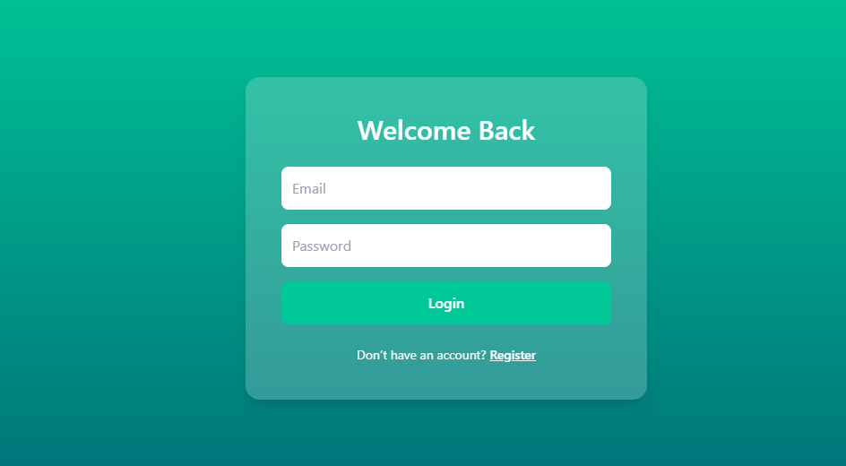

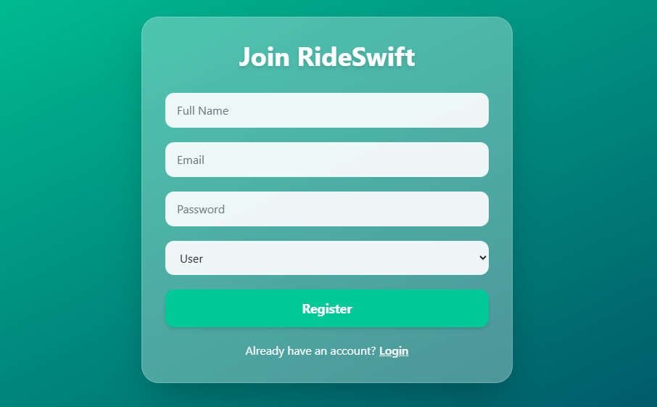
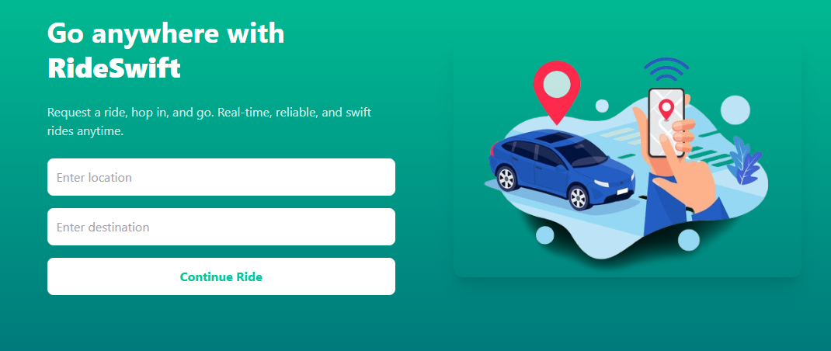

- TOOLS USED
  - Front End

- HTML : used to create structure of the website.
- CSS : Cascading Style Sheets is a style sheet language used for specifying the presentation and styling of a document written in a markup language such as HTML.
- JavaScript : JavaScript is used to add functionality to the website.
- React.js : React.js is a JavaScript library for building user interfaces.
- Tailwind CSS: Tailwind CSS is a utility-first front-end framework for building modern, responsive, and visually appealing websites and web applications. It allows developers to style elements directly in HTML using predefined utility classes, enabling rapid and highly customizable UI development without writing custom CSS.

  - Back End
- Node.js: Node.js is a runtime environment that allows you to execute JavaScript code on the server side, enabling scalable and efficient network applications.
- Express.js: Express.js is a web application framework for Node.js, designed to build robust and efficient web applications and APIs with ease.
- MongoDB: MongoDB is a popular NoSQL database management system that uses a document-oriented data model to store and retrieve data, providing flexibility and scalability for modern applications.

- TESTING
Testing is the stage of implementation, which is aimed at ensuring that the system works accurately and efficiently before live operation commences.

  - Objective of Testing
The objective of testing is to find bugs that may exist, mainly through the implementation of the whole program. A good testing scheme can achieve not only the goal of finding bugs but also the goal of maximizing efficiency.

  - Testing Methods/Techniques used
- Unit Testing: Testing small parts (units) of the program one by one to make sure they work correctly on their own.
- Integration Testing: Testing how different parts of the program work together. This checks if they communicate and function well together.
- System Testing: Testing the whole program as a complete system to see if it meets all requirements and works properly.

  - Test Case Design(Manual/Automated)
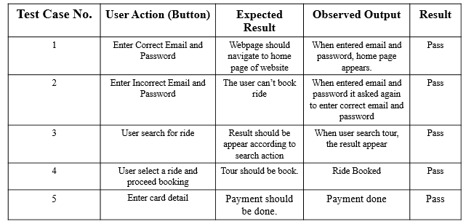
Table 7.1 Test Cases

- IMPLEMENTATION
There are two types of functions given for execution of system i.e. the Captain Function and User Function.

8.1 Captain Functions
a. Captain can log in.
b. Captain can view available ride requests from users.
c. Captain can accept or reject ride requests.
d. Captain can view and update their profile and vehicle details.
e. Captain can mark rides as started or completed.
f. Captain can log out.

8.2 User Functions
a. User can sign up and log in.
b. User can select source and destination.
c. User can view available vehicle options.
d. User can book a ride and view ride details.
e. User receives OTP to start the ride.
f. User can track ride status and location.
g. User can make payment via QR code after ride completion.
h. User can view ride history.
i. User can log out.

  - Screen Layout
- Figure 8.1 Shows Register page
- Figure 8.2 Shows Login page
- Figure 8.3 Shows Home page
- Figure 8.4 Shows User-Dashboard page
- Figure 8.5 Shows Captain Dashboard page
- Figure 8.6 Shows Booking page
- Figure 8.7 Shows Payment page

Figure 8.1 Register page

Figure 8.2 Login page

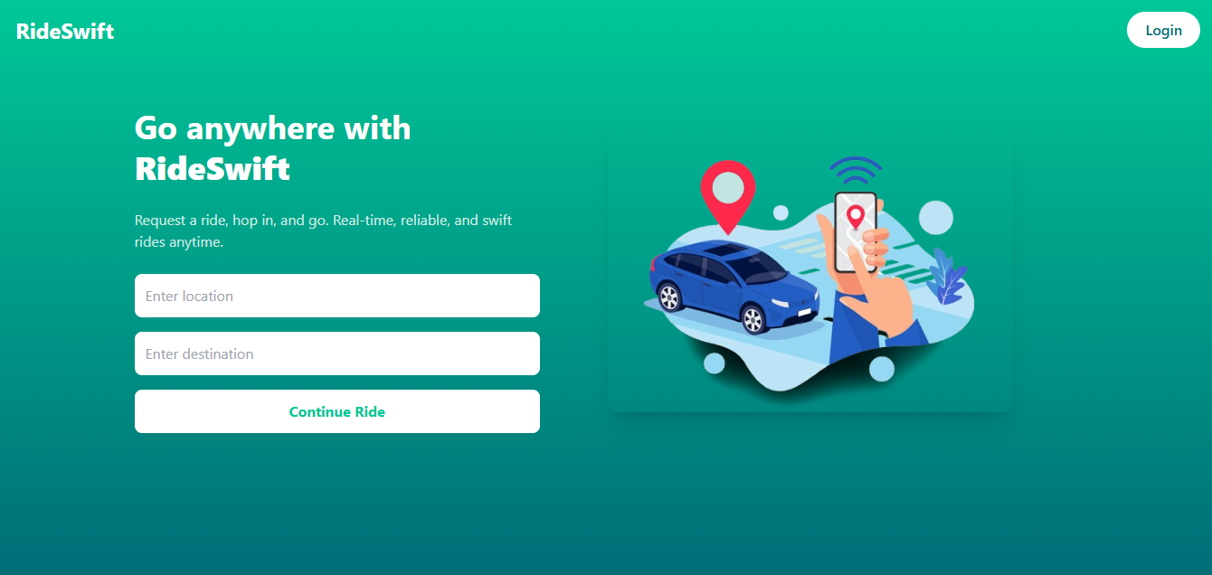
Figure 8.3 Home page

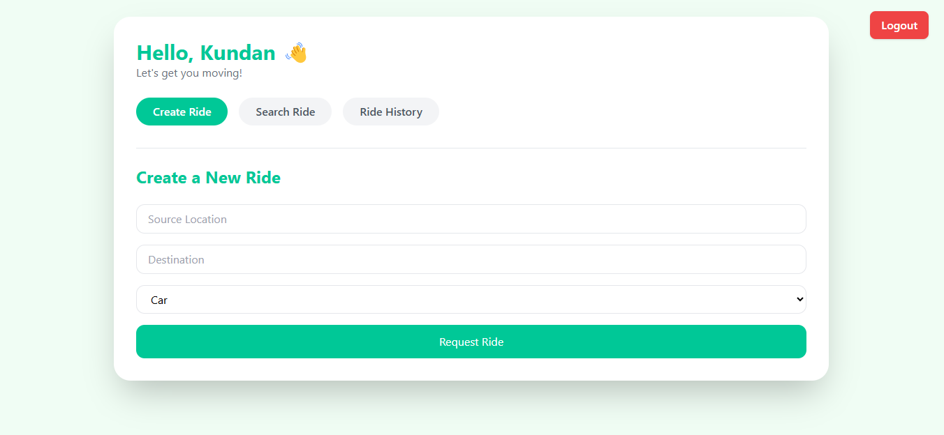

Figure 8.4 User-Dashboard page
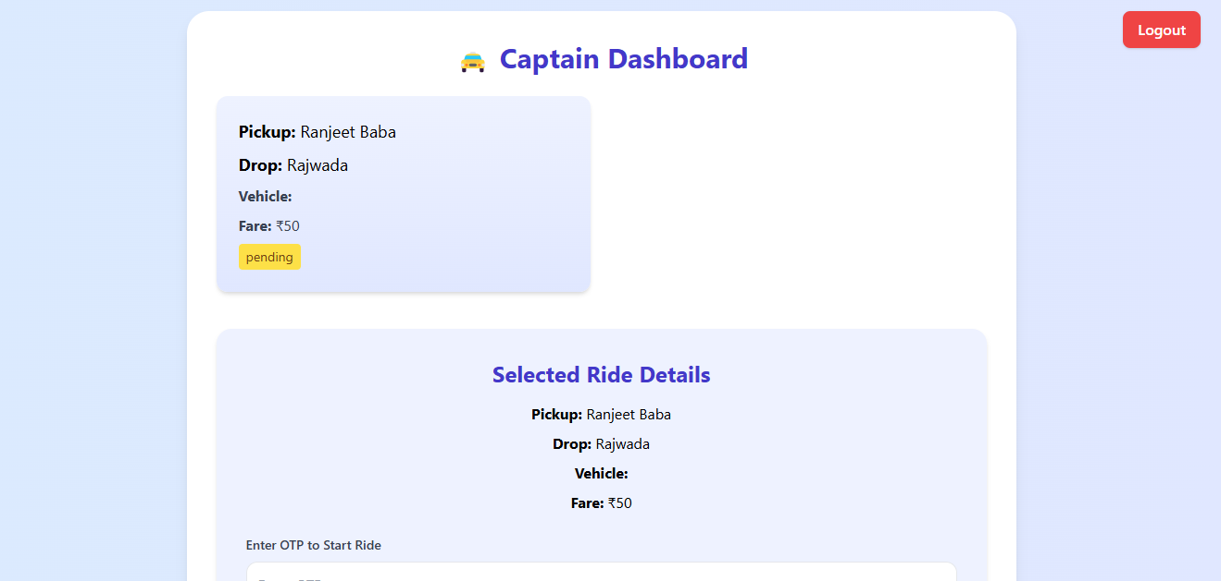
Figure 8.5 Captain-Dashbaord page

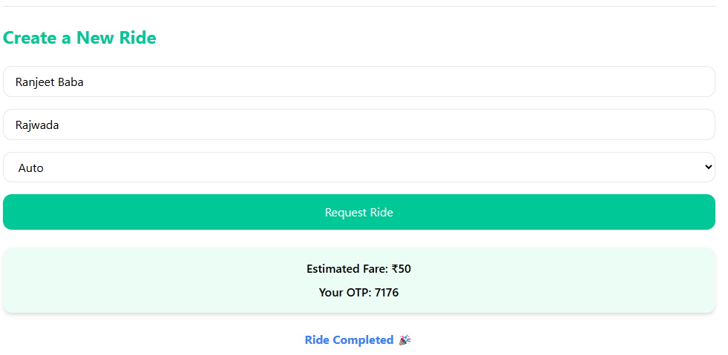
Figure 8.6 Booking page
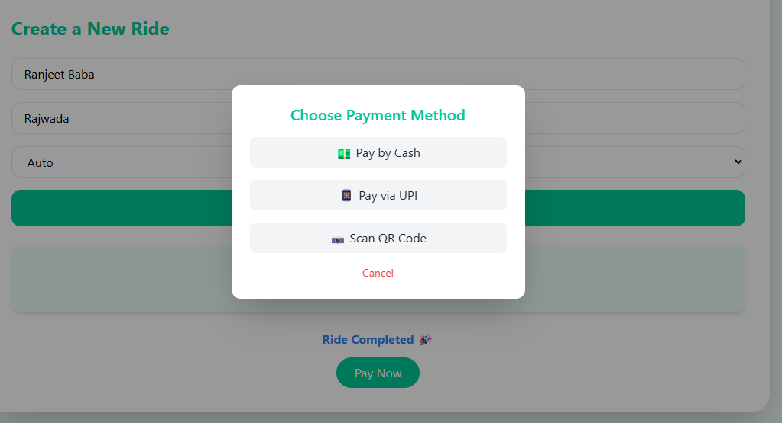
Figure 8.7 payment page

- CONCLUSION
Every project has a start and an end but the most difficult part is to reach to the conclusion.
  - Difficulties encountered during project
- During the initial development stage of the project, my lack of knowledge in Node.js caused some difficulties in implementing it correctly.
- During the development analysis phase, I faced challenges in determining the best starting point for the project.
  - Limitations of the System
  - Payment Gateway Integration: The system currently lacks a payment gateway for users to pay publishing fees. This means users cannot submit paid content at this time.
  - Accuracy: Despite improvements in the technology, RideSwift is not 100% accurate.
  - Scope of future enhancements
- Globalization of site
- Some more new categories may be added.

- BIBLIOGRAPHY
Websites
- “w3schools”, “JavaScript”, https://www.w3Schools.com
- “geeksforgeeks”, “React.js”, https://www.geeksforgeeks.org/react-tutorial
- “coder’s gyan”, “Node.js”, https://www.youtube.com/c/CodersGyan
- “geekyshows”, “Express.js, mongoDB”, https://www.youtube.com/c/Geekyshows

